## Recap

Data traffic over network is increasing every moment, within the conventional networking system we can make flow of data from any point to any point, but manipulating according priority, increasing flexibility is tough. With the blessing of Software Defined Networking (SDN) we can decouple the system that makes decisions ( control layer) about where traffic is sent from the underlying systems that forward traffic to the selected destination therefore giving priority and flexibility to a certain sort of flow become easier. SDN is not only Implementing network functions in software or on virtual Machine

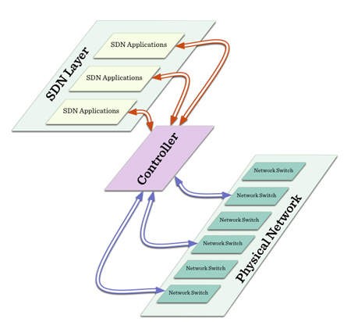

Fig: 1 SDN and OpenFlow

OpenFlow is a standard that enables remote controllers to find out path of network packet through the switches, it is used for applications such as virtual machine mobility 1 . OpenFlow allows remote administration of a switch's packet forwarding tables so that decision can be made as per demand. Researchers consider it is an enabler of Software defined networking (SDN). In a conventional route data path and control path created on the same device but OpenFlow separates these- packet forwarding d path lays on the switch but routing decisions are moved to a separate controller. Router and Controller communicate via the OpenFlow protocol.

Network functions virtualization (NFV) decouples the network functions, e.g. NAT, DNS, firewalling, intrusion detection and caching from proprietary hardware appliances so they can be run in software. The main difference between SDN and NFV is, SDN remove management and control planes from network device, NFV omit need for special hardware.

HP is the leader of SDN technology, in the year 2007 they start collaboration with Stanford university , 2008 they demonstrate OpenFlow concept. First OpenFlow switch came in market at 2011. Demand of scalability and programmability of network would help to grow SDN market to $3.7 billion by 2016.

## Problem:

Presentation were based on graph, chart and technical specification of different methods and standard, and explain briefly. Many time I had to watch YouTube lecture to clear the concept. Why we should move to SDN was not clear to me.

## Criticism:

According Ashton and Metzler 3 "SDN controller is a single point of failure and hence the controller decreases overall network availability." To avoid this breakdown some techniques are being discussed, one of that is SDN to have ability to find out multiple path form source to destination so that, the availability of the solution is not impacted by the outage of a single link.

## Deepening:

SDN is an emerging architecture that is dynamic, manageable, cost-effective, and adaptable, making it ideal for the high-bandwidth, dynamic nature of modern applications. It is directly programmable, agile, centrally controlled and vendor neutral. Architecture of SDN mainly divided into two part:

* Control plane
* Data plane

control plane contains control applications and network operating system while data plane works with forwarders / routers. Routing, multicast, security, access control, bandwidth management, QoS, traffic engineering, processor and storage optimization, energy usage are API facilitated.

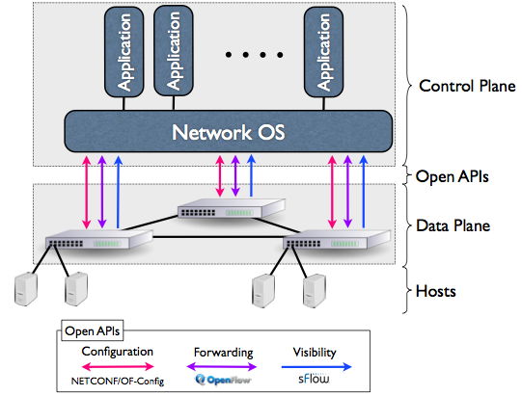

Fig2: SDN Architecture

All SDN models have an SDN Controller, southbound APIs and northbound APIs. Southbound APIs are used to relay information to the switches and routers while use of northbound APIs to communicates with the applications and business logic.

# Reference:

1. http://archive.openflow.org/wp/learnmore/

2. https://www.youtube.com/watch?v=2BJyIIIYU8E

3. https://www.necam.com/docs/?id=23865bd4-f10a-49f7-b6be-a17c61ad6fff

Khandker, Syed Ibrahim

WISE